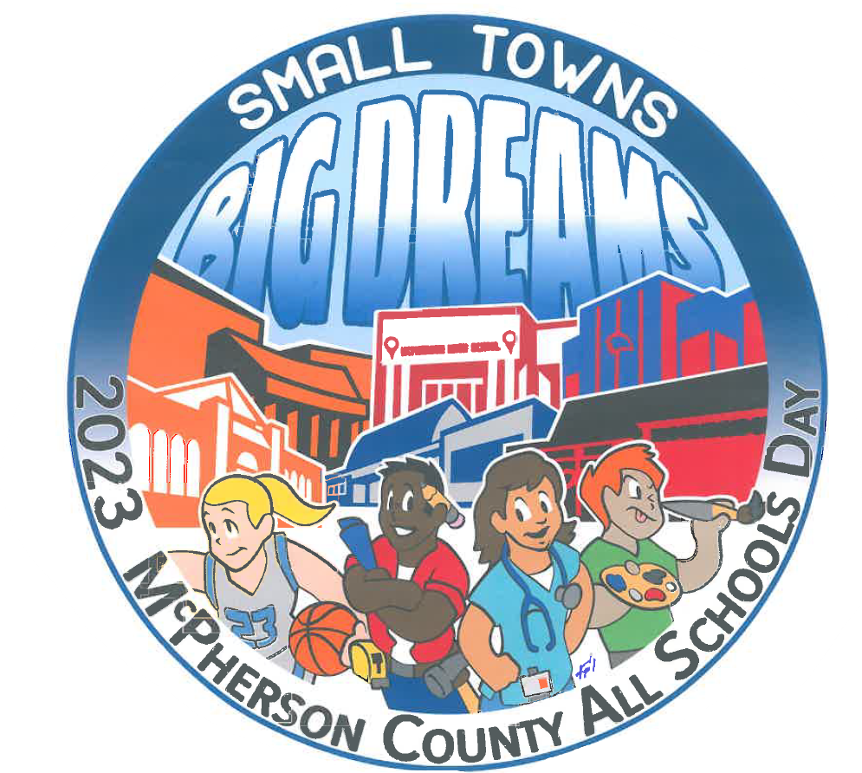
111th ANNUAL McPHERSON COUNTY ALL SCHOOLS DAY BUTTON DESIGN CONTEST

THEME: Stories That Live Forever

Please submit your design by 5:00 pm, Friday, February 16, 2024 to:
McPherson County All Schools Day Committee
PO Box 115

McPherson KS 67460
Or you may deliver items in person to Mary Steffes, Fee Insurance Group, 110 E. Elizabeth, McPherson, KS 67460 by the deadline mentioned above.

DESIGN SPECIFICATIONS:
- Design must be no larger than 11 inches in diameter. (Note: the winning entry will be reduced to fit on a button that is approximately 2 inches in diameter.)
- No limit in number of colors; white background
- All artwork must be original. Original computer-generated graphics are permitted. However, the use of clip art is prohibited.
- Design must be camera-ready.
- A brief description of your design will be permitted, though it is not necessary. The design itself should explain the theme.
- Multiple entries by individuals are encouraged.
- Design must include:
  - The theme (in words): Stories That Live Forever
  - The words: McPherson County All Schools Day
  - The Year: 2024
  - Your signature(s)

JUDGING AND AWARDS:
- First Place will be a cash prize of $200.
- Judging of entries will be done by the ASD Executive Board.
- All designs become the property of the ASD Committee and may be used at the sole discretion of the ASD Committee.
- All decisions are final.

PLEASE COMPLETE THIS FORM AND RETURN IT ALONG WITH YOUR ENTRY
Applicants must have connections to McPherson County

Name ______________________________________________________________________

Address _____________________________________________________________________

Phone Number_________________________ E-mail Address___________________________

I HAVE READ AND AGREE TO THE TERMS ABOVE

Signed: ______________________________________ Date: _________________________

Past button designs may be seen on the Button Collection page at www.allschoolsday.com
Like us on Facebook at McPherson County All Schools Day!

